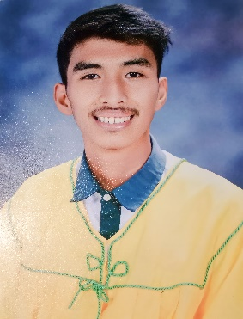**Dether S. Lagos**

**Purok Gumamela,Tiayon**

**Tiayon Ipil Zamboanga Sibugay,7001**

**detherslagos@gmail.com**

**09356693646**

**OBJECTIVE:**

I am dedicated to utilizing my existing knowledge and working diligently to become an essential team member. I aspire to contribute effectively by merging academic insights with hands-on expertise for organizational success.

**EDUCATION:**

2023 - 2024 Dr. Aurelio Mendoza Memorial Colleges

Poblacion,Ipil Z.S.P

Bachelor of Science in Computer Science (BSCS)

2018 - 2019Dr. Aurelio Mendoza Memorial Colleges

Poblacion,Ipil Z.S.P

General Academic Strand (GAS)

2013 - 2014 Tiayon Elementary School

Tiayon Ipil Z.S.P

**ON-THE-JOB TRAINING EXPERIENCE:**

**OJT Position**

* Baranggay Hall of Tiayon
* Baranggay Office Staff
* Baranggay Health Center of Tiayon
* Baranggay Health Center Staff
* DayCare Center
* Teacher Assistant

**EXPERIENCE AND ACHIEVEMENTS:**

- Received Certificate Participating in ICT Summit 2023 Website Development Competition.

- Expanded computer skills and acquired additional knowledge during the OJT period.

- Received positive feedback from supervisors, both in the form of valuable advice and commendations for my work.

**SKILLS:**

Microsoft Office:

* Proficient in Word for document creation.
* Skilled in PowerPoint for dynamic presentations.

Graphic Editing:

* Capable of editing pictures with attention to detail.